**MSc project**

RFID localization for autonomous cooperative driving

SEGULA Technologies Nederland BV is a part of the international SEGULA Technologies Group with 7000 employees in 19 countries. SEGULA is one of Europeans leading engineering companies with a strong experience and position in automotive and aerospace engineering. As development partner for many OEM companies in automotive, healthcare, high-tech components and systems industry, SEGULA contributes with new concepts and innovative solutions to different highly strategic engineering projects.

To remain highly competitive at demanding high-tech and automotive markets in The Netherlands and abroad, SEGULA has to keep up with the state-of-the art technological developments in the fields of mechatronics and robotics. Among emerging technologies, commercial sector gives increasing attention to object identification, localization and tracking based on radio frequency identification (RFID). This technology seems as a revolution in industrial control, because it has the potential to simplify and make more robust tracking of parts or part carriers through manufacture, storage, distribution, and at the end of the supply chain. Furthermore, RFID has promising potentials for localization of vehicles (cars, busses, trucks) on the road as well as mobile robots and automatic guiding vehicles (AGV’s) in warehouses, havens, and at the airports. Accuracy, portability, cost-effectiveness, and robustness to environmental conditions are the main out of several advantages of the RFID against other technologies used for object localization, such as GPS, radar, liar, sonar, camera’s, etc. That is why it seems inevitable that SEGULA masters the RFID-based technology and, in particular, its application to localization of the vehicles and mobile robots.

In many applications, we encounter a group of mobile robots that cooperate with each other. Examples are robots that perform complex or spatially distributed tasks, such as simultaneous localization and mapping, transportation of bulky payload, enclosing an invader, exploration of an unknown environment, carrying mobile sensor network, playing football, etc. Mobile robots are also increasingly being used for automatic transport of materials and goods in manufacturing systems, warehouses, cross-docking centres and container terminals. In all these applications the robots must cooperate with each other in order to achieve high throughput transportation which is robust to disturbances (e.g. in communication) and system errors (e.g. failures of individual robots). The cooperation also contributes to flexibility of transportation, since it facilitates on-the-fly changing number of the involved robots and variations of their tasks. To make their cooperation possible, it is essential to enable autonomous robot navigation, which requires knowledge of the robots’ Cartesian and orientation coordinates.

A particular form of cooperation is maintaining the desired geometric pattern between the robots that we call a formation. In Figure 1, we see a group of mobile robots that establish a platoon-like formation. In practice, there is an objective to establish the desired formation automatically and without collisions. Formation control of so-called unicycle mobile robots is particularly challenging, since these robots cannot make sideways movements without slipping because of their non-holonomic kinematics. That means that the input forward and steering robot velocities, on one hand, and its Cartesian and angular velocities, on another, feature a nonholonomic constraint which especially complicates formation control design and stability analysis.

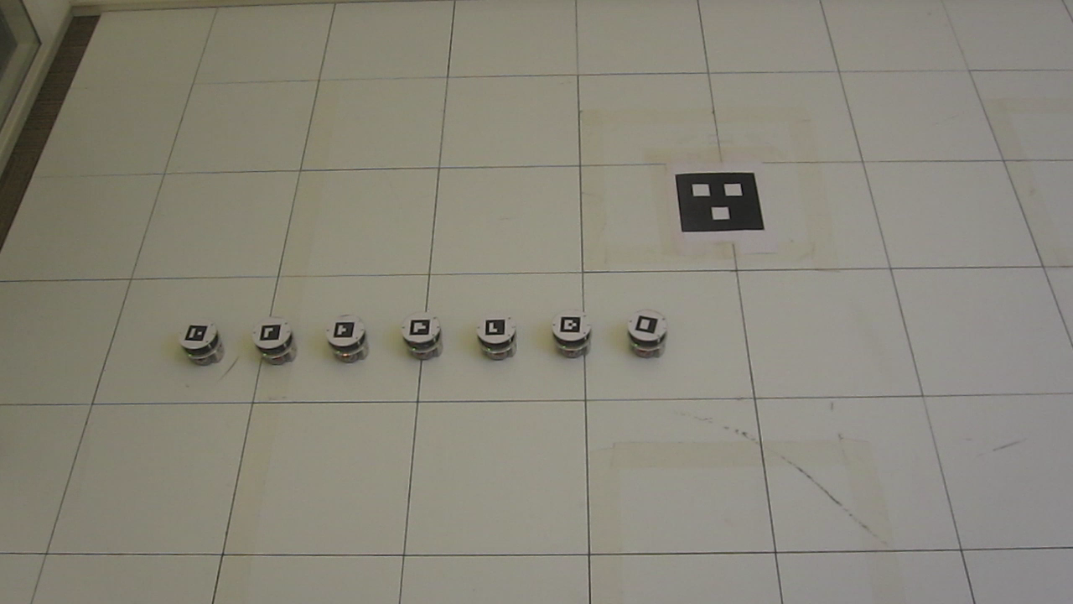

Figure 1: A platoon-like formation of mobile robots  
(model E-puck, available at the Dynamics and Control Group, TU/e).

In references [1-7], the problem of simultaneous trajectory tracking and formation control of unicycle robots is studied. To solve this problem, distributed control algorithms are proposed that are robust to perturbations on the robots and prevent their collisions. Quality of these algorithms is investigated in simulations [1-7] and experiments with e-puck robots [1-5,7]. So far, the main focus of the experimental studies has been on real-time implementation of the control algorithms and their performance evaluation. For convenience, the robot localization has been done using a centralized overhead camera system. Although that system simplifies measurement of the actual robot planar coordinates, it is hardly suitable for deployment in practical applications due to limited measurement range and high sensitivity to changes in lighting conditions. That is why another solution for robot localization is needed which will enlarge operational range of the mobile robots and increase robustness against changes in their working environment.

An RFID-based localization [8-11] of the mobile robots is an appealing alternative to the use of camera systems. An illustrative example is shown in Figure 2.



Figure 2: A RFID-based robot localizaton setup.

In this MSc project, an embedded system will be used for RFID-based localization of mobile robots and their formation control based on algorithms from [1-7]. Functionality and performance of that system will be demonstrated in a problem of cooperative floor cleaning by means of autonomous vacuum cleaning robots (e.g. [12]). In that (virtual) demonstration, two, three or four vacuum cleaning robots will carry out the floor cleaning while forming two-edge, triangular or rectangular geometric pattern, respectively. There is one robot physically available to perform tests with. The current robot platform consists of a vacuum cleaning robot with RF equipment and embedded system architecture (hardware and software). The challenge is to integrate all sensor inputs, sensor fusion, so they can be used for the new controller design that needs to be developed. and to construct the path planning for both a single robot and the platoon itself. choose that are capable to demonstrate distributed formation control of unicycle robots using RFID localization of high accuracy (Cartesian errors within , orientation error within ). Some electronics hardware upgrades could be possible to simplify the system.

The particular assignments are:

1. Perform literature study on different localization techniques for the mobile robots with a focus on RFID localization.

2. Get familiar with the theory of trajectory tracking and formation control algorithms for unicycle mobile robots.

3. Integrate the selected sensing technique into the existing algorithms for trajectory tracking and formation control.

4. Evaluate the resulting formation control strategy in simulations.

5. Implement the strategy on the robot platform present.

6. Give demonstration of autonomous floor cleaning (using the cooperative vacuum cleaning robot).

7. Document the result in a written report.

Results achieved during this MSc project will be documented in a written report and oral presentations will be given at the SEGULA and TU/e. SEGULA is responsible for hosting the student and will provide coaching on the aspects of the mobile robot modelling, localization and formation control. Academia will be responsible for coaching on sensor fusion.

The results of this project will be instructive for development of autonomous mobile transport systems for manufacturing facilities, warehouses and havens, automatic platooning of trucks, busses and cars, realization of mobile sensor networks, etc.

**References**

|  |  |  |  |  |
| --- | --- | --- | --- | --- |
| **Ref** | **Title** | **ID** | **Date** | **Author** |
| [1] | Saturated control of time-varying formations and trajectory tracking for unicycle multi-agent systems | IEEE Conf. on Decision and Control, pp. 4054–4059 | 2010 | D. Kostić, S. Adinandra, J. Caarls, N. van de Wouw, H. Nijmeijer |
| [2] | A Virtual Structure Approach to Formation Control of Unicycle Mobile Robots using Mutual Coupling | International Journal of Control, Vol. 84, No. 11, pp. 1886-1902 | 2011 | A. Sadowska,  T. van den Broek, H. Huijberts, N. van de Wouw, D. Kostić, H. Nijmeijer |
| [3] | Collision-free Tracking Control of Unicycle Mobile Robots | IEEE Conf. on Decision and Control, pp. 5667-5672 | 2009 | D. Kostić, S. Adinandra, J. Caarls, N. van de Wouw, H. Nijmeijer |
| [4] | Distributed Formation Control and Trajectory Tracking of Multiple Unicycle Mobile Agents | Int. Conf. on Robotics and Automation, pp. 1564-1569 | 2012 | A.D. Sadowska, D. Kostić, N. van de Wouw, H.J.C. Huijberts, H. Nijmeijer |
| [5] | Distributed Formation Control and Trajectory Tracking of Multiple Unicycle Mobile Agents | Article in preparation |  | A.D. Sadowska, D. Kostić, N. van de Wouw, H.J.C. Huijberts, H. Nijmeijer |
| [6] | Collision-free cooperative control of unicycle mobile robots with saturated input velocities | D&C report, TU/e | 2014 | F.H.A. Monsieurs |
| [7] | Experimental evaluation of collision-free trajectory tracking control of unicycle mobile robots | D&C report, TU/e | 2015 | J. Smit |
| [8] | A review of RFID localization: Applications and techniques | Proceedings of ECTI-CON 2008, pp.769 - 772 | 14-17 May 2008 | T. Sanpechuda, L. Kovavisaruch |
| [9] | RFID localization algorithms and applications—a review | Journal of Intelligent Manufacturing, Vol. 20, pp. 695–707 | 2009 | J. Zhou, J. Shi |
| [10] | The history of RFID | IEEE Potentials. Vol. 24, No. 4, pp. 8-11 | 2005 | J. Landt |
| [11] | Intelligent moving service robot navigation technique using RFID technology for transportation inside SMEs | Int. Conf. SMEs Development and Innovation: Building Competitive Future of South-Eastern Europe | October 3-4, 2014 | T. Latinović, S. Deaconu, M. Latinović, M. Lazarević, C. Barz |
| [12] | How to Program Roomba – Introduction | www.robotappstore.com/Knowledge-Base/1-Introduction-to-Roomba-Programming/15.html |  | A. Sandler |